RBO Hand 3: A Platform for Soft Dexterous Manipulation

# Abstract

The RBO Hand 3 possesses 16 independent degrees of actuation, implemented in a dexterous opposable thumb, two-chambered fingers, an actuated palm, and the ability to spread the fingers.

# I. INTRODUCTION

RBO Hand 3 is highly compliant, underactuated, pneumatically actuated, and fabricated predominantly from soft materials such as fabric or silicone rubber.

The starting point for the design process of the RBO Hand 3 were three assumptions. First, we believe Mason’s metaphor of a *funnel*, formulated in 1985, as “an operation that eliminates uncertainty mechanically” [7], to be the central enabling concept for dexterous manipulation. This metaphor provides a concise explanation for the effectiveness of exploiting environmental constraints, namely, reducing uncertainty through mechanical interactions. With RBO Hand 3, we extend this funnel concept to dexterous manipulation in general by also considering exploitation of constraints that are provided by the manipulation platform. Second, we continue to rely on an anthropomorphic design,

# III. RELATED WORK

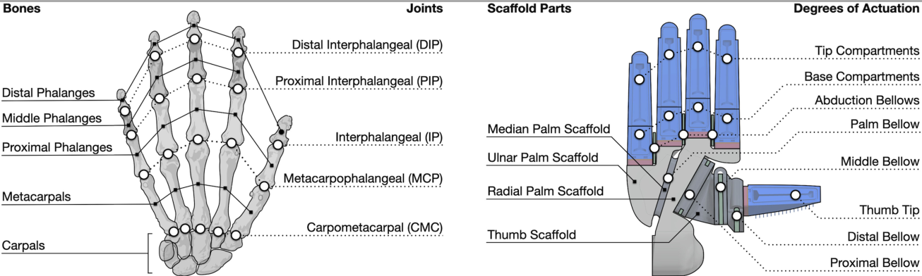

*Fig. 2. RBO Hand 3 is inspired by its human counterpart: nomenclature of joints and bones in the human hand (left) and corresponding naming of features in the RBO Hand 3 (right).*

# IV. REALIZATION OF THE DESIGN OBJECTIVES

## Compliant Actuation

1) *PneuFlex Actuator*: All five digits of the RBO Hand 3 rely on the soft pneumatic PneuFlex actuator[1],which has been used already in our hand’s predecessors. Because this actuator is an essential part of the design of the RBO Hand 3, we will shortly reiterate its basic functioning: the PneuFlex actuator relies on an inflatable silicone air chamber whose radial expansion is constrained by a thread helix.

2) *Bellow Actuator*: Unlike its predecessors, the RBO Hand 3 relies on a second type of compliant actuator: the bellow actuator.

3) *Pneumatic Control*:

## Enabling Dexterous Manipulation

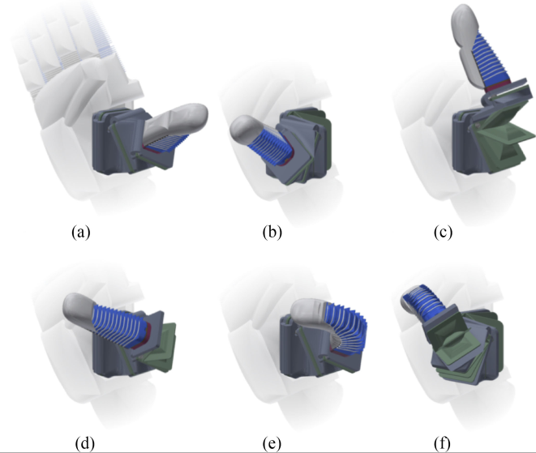

*Fig. 5. Thumb actuators and resulting movements upon inflation. (a) No actuator inflated. (b) Proximal bellow for anteposition. (c) Middle bellow for abduction. (d) Distal bellow for flexion. (e) Thumb tip for flexion. (f) All actuators partially inflated.*

We will now outline the related design features.

1. ***Two-Compartment Finger***: The four fingers of the RBO Hand 3 are based on the PneuFlex actuator with two actuated degrees of freedom (see Fig. 3).
2. ***Dexterous Opposable Thumb***: The thumb design plays a pivotal role in achieving dexterity in the RBO Hand 3. Our goal is to replicate the diverse abilities of the human thumb that is capable of the following movements: flexion moves the tip of the thumb in the direction of its pulp, perpendicular to the plane of the thumbnail. Extension is the inverse movement to flexion. Abduction moves the thumb away from the index finger.
3. ***Palm Hollowing***: During our design studies, we learned that the commitment to an anthropomorphic hand design also necessitates the implementation of palm hollowing [46] via an additional actuated degree of freedom in the RBO Hand 3.
4. ***Finger Abduction***: The fingers of the human hand are able to move apart and together (abduction and adduction, respectively), thanks to their condyloid type metacarpophalangeal joints. This permits the fingers to better encompass the object and to exert forces from different directions, which facilitates robust grasping and manipulation. To replicate these movements with the RBO Hand 3, we place abduction bellows (each consists of two pouches) between the base-compartments of neighboring fingers (see Fig. 2), which deform laterally when inflating these actuators. The ability of abducting the fingers increases their workspaces, and thus, improves the dexterity and versatility of the RBO Hand 3
5. ***Soft Layer***: The RBO Hand 3 exhibits substantial inherent mechanical compliance. This newest version of our soft hands further increases the compliance of its fingers and its palm by equipping them with a soft layer.
6. ***Summary***: Enabling Dexterous Manipulation: In total, the RBO Hand 3 has 16 actuated degrees of freedom based on intrinsically compliant pneumatic actuators: eight in the four fingers, four in the thumb, three for abduction of the fingers, and one for palm hollowing.

## Support Extensive Real-World Experiments

# V. ACTUATOR CHARACTERIZATION

## A. Characterization of the Two-Compartment Finger

In Section IV-B1, we demonstrated the two-compartment finger’s large workspace and its ability to exert strong forces over large regions of its workspace, highlighting its significancefor the RBO Hand 3 to form diverse manipulation funnels.

# VI. EVALUATION OF THE RBO HAND 3

## A. Thumb Opposability

We use the Kapandji test [42] to compare the functionality of our thumb design to its human counterpart while evaluating its opposability.

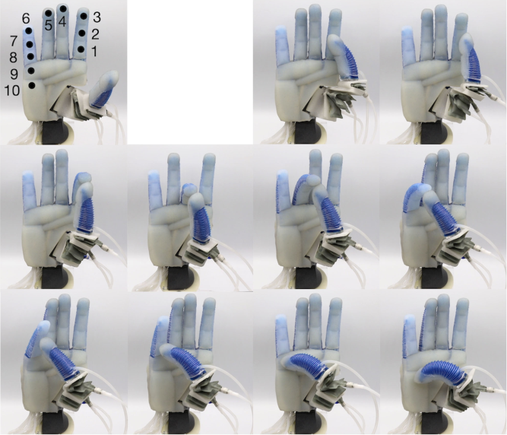

*Fig. 9. RBO Hand 3 achieves the highest possible score in the Kapandji test thanks to its dexterous, opposable thumb, which is able to reach all ten locations on the hand.*

## B. Grasp Postures

We assess the dexterity and versatility of the RBO Hand 3 by showing that it is capable of achieving many different grasping postures. A common practice to measure a hand’s grasping capabilities is to reenact common human grasps.

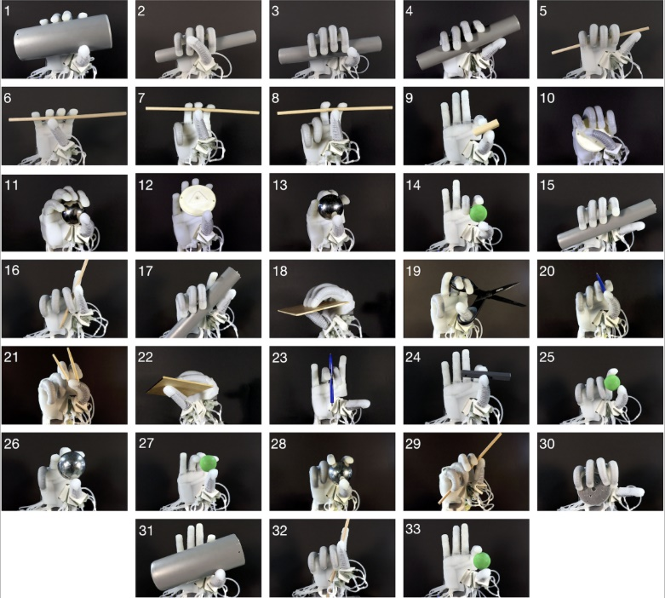

## C. Grasp Strength

We demonstrate the overall strength of the RBO Hand 3 by showing that it can firmly hold an object onto which pulling forces are applied. The ability to withstand external forces, such as gravity, depends on the strength of the hand’s actuators and indicates its ability to grasp and manipulate heavy objects. The higher the required forces to pull-out an object, the stronger the hand’s actuators and vice versa.

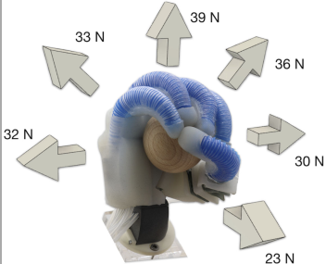

*Fig. 11. Object pull-out experiment. A force–torque sensor connected to the object via an inextensible wire measures the required force to pull the object out of the closed hand in different directions. Arrows indicate pulling directions and numbers indicate corresponding pull-out force, averaged over five trials. Standard deviation is below 3 N for each direction.*

## Replicating Human Grasping Strategies

To verify the design objective that the RBO Hand 3 should facilitate transfer of human strategies, we replicate the threemost frequent tabletop grasping strategies observed in humans.

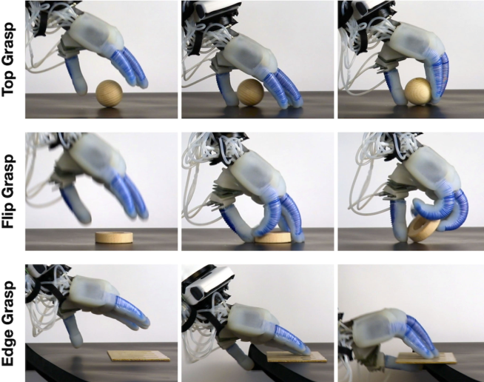

*Fig. 12. RBO Hand 3 replicates the three most commonly observed human grasping strategies. Top grasp: During hand closure, fingertips move inwards while being guided by the support surface. Flip grasp: The thumb fixates the object before it is rotated by the fingertips. Edge grasp: Hand slides the object toward the edge of the support surface before grasping it from the side. From left to right: Hand approaches the object, exploitation of environmental constraints (the tabletop), hand closes to grasp the object.*

## E. In-Hand Manipulation

We demonstrate the dexterity of the RBO Hand 3 by performing three simple in-hand manipulations during which the hand rotates three different objects (pen, screw driver, and plastic banana) about the proximal-distal axis, the ulnar-radial axis, and the palmar-dorsal axis (see Fig. 13). The ability to perform diverse manipulations with a wide variety of objects inside the hand shows a high level of dexterity.

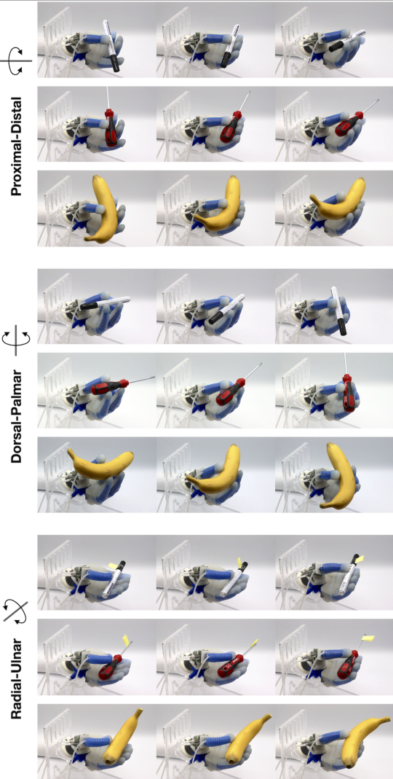

*Fig. 13. RBO Hand 3 performs simple in-hand manipulations. Three different objects (pen, screw driver, and plastic banana) are rotated inside the hand about the (top) proximal-distal axis, (middle) dorsal-palmar axis, and (bottom) radialulnar axis. For each of these three rotation types, the hand performs the same actuation pattern irrespective of the object. To achieve these maneuvers, only a subset of the actuators is inflated, while the rest of the hand serves as a spatial arrangement of compliant constraints, which passively adapt their shape to the movement of the object, resulting in complex behavior despite simple control.*

# VII. LIMITATIONS AND FUTURE WORK

## A. Ambivalence of Soft Material Robotics

soft material robots are often believed to be limited to low forces, they pose new challenges for sensorization, exhibit imprecise actuation, and it is difficult to find accurate analytic models. We now want to discuss these drawbacks in more detail.

Maximum forces achieved by soft pneumatic fingers tend to be lower than that of their rigid counterparts, because flexional forces can be diverted when soft fingers bend away from the object due to low lateral and torsional stiffness. Furthermore, soft material actuators can break at high levels of air pressure, which are necessary for achieving high forces. These problems can be addressed by embedding a rigid skeleton into the soft finger in order to achieve kinematic stiffness and transmission of forces while decoupling contact location and acting forces.